

Not Their First Rodeo
by Rebecca Holland • May 9, 2016 • Leave a Comment
The Lake Forest Police Department is gearing up for its fifth annual Bike Rodeo, where kids can make sure their bikes are ready for summer, navigate their way through obstacle courses, and win free prizes.
“We want to educate both kids and parents and promote bike
safety on the roads and on the sidewalks,” says Officer Rob Monahan, the officer who founded and still organizes the event.
On Saturday, May 21, from 10 a.m. to 2 p.m. families can stop by the Oakwood parking lot across from City Hall for bicycle safety lessons, skill stations, free prizes, and free food, all made possible by the Lake Forest Police Foundation, the event’s sponsor.
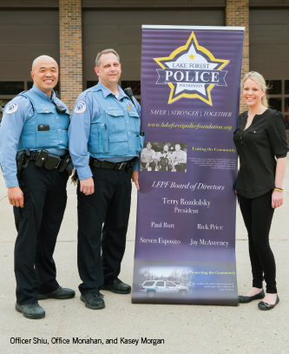
“The event is free, free, free,” says Monahan. “We just want to promote safety. All kids have to do is bring their bike.”
At the rodeo, kids make their way through 10 bicycle skill stations. At the helmet check station they’ll learn how to make sure their helmet fits properly; at another station they’ll work with Kiddles Sports to make sure their seat is the correct height, their tires are full, and their chains are working correctly; and at the ‘Operation Lifesaver’ station, Metra will demonstrate how to cross railroad tracks when on a bike. The remaining skill stations are obstacle courses where kids can maneuver through cones, learn how to read traffic signals, take on a fake newspaper route, test their balance, and more.
“Through this event and teaching bike safety in local schools, we’ve been able to teach kids what they need to know to prevent accidents,” Monahan says.
He notes that accidents don’t always happen on the road, but can happen on sidewalks too if someone is backing out of their driveway and doesn’t see a child riding past. Monahan and his colleagues teach both children and adults to be aware in all situations, to reduce accidents as much as possible.
Monahan says teaching children about bike safety has had other positive impacts as well.
“I’ve been a police officer for 16 years, and a juvenile officer for many of those, and I’ve seen that through interacting with the kids on a regular basis, they feel comfortable coming to us, the police, when they have problems,” he says. “I think it’s important that they feel comfortable approaching me and talking to me about issues, whether generally speaking or when they’re in trouble.”
He hopes to keep reaching new children in the community.
When the Bike Rodeo started in 2011, about 75 kids showed up.
Last year, there were more than 200 kids participating, and about 450 visitors total. This year, the first 300 kids to arrive receive a free t-shirt, a free bicycle helmet, and an entry into a drawing for one of four bikes, donated by the Lake Forest/Lake Bluff Lions Club and Bob’s Pedal Pusher Bike Store. Throughout the event, officers will give away bike lights, locks, and other accessories.
All participants receive a free hot dog lunch.
Perhaps one of the most exciting features for kids is the return of last year’s highlight, a demonstration from BMX superstar Marshall Gehrke, a 6th grader who competes nationally and is ranked sixth in the world.
Another local officer, Officer Grum, will be donating an inflatable bouncey house, and Officer Cerer, who drives racecars in his spare time, will bring a few of his cars for kids to admire.
Monahan notes that though he has been working on the event from the beginning, it wouldn’t be possible without the help of Officer Shiu and Kasey Morgan, an organizer from the Lake Forest Police Foundation.
“It’s a great event for the whole family to learn about bike safety and have some fun,” Monahan says. “We hope to see all Lake Forest’s families there—just don’t forget your bike and helmet!”

