Opinion: Open Letter to Lake Forest/Lake Bluff
by Opinion Writer • February 24, 2016
In the New Year, one often becomes introspective and thankful. I am here to exclaim my most sincere thanks to our valued customers. It is with the utmost respect that my family operates Kiddles Sports, always remembering we can’t plan for the future without giving full attention to our past.
My introspection revolved around the very nature of conducting commerce in 2016 and the future. There exists no secret about the growth of internet business. An array of pundits, advisors and media align themselves with calling out the demise of “brick and mortar” shops. It is my humble opinion that small shops, family businesses, and boutique stores are the first in line to gladly sponsor their communities’’ programs when asked. Schools, churches, charities are all in need of our assistance and my fellow shop owners in Lake Forest/Lake Bluff are always benevolent towards these causes. Community mindedness is ‘top of mind’!
I am equally confident that we all inventory our perspective stores with necessities specific to our local customers’ needs. To do so properly means listening, studying and acting upon. Our “skin in the game” prowess cannot be mimicked, of that I am certain.
My voice is resolute and based upon four decades of retail in Lake Forest/Lake Bluff. The clear intent of my family is to continue a quality second to none. This will always be our mantra going forward because since 1968, our mission statement has never waivered.
Our New Years’ wish to everyone is one of health and prosperity. From my family to yours, a sincere and heartfelt thank you for your confidence, commitment and friendship.
The Shlifka Family
Kiddles Sports
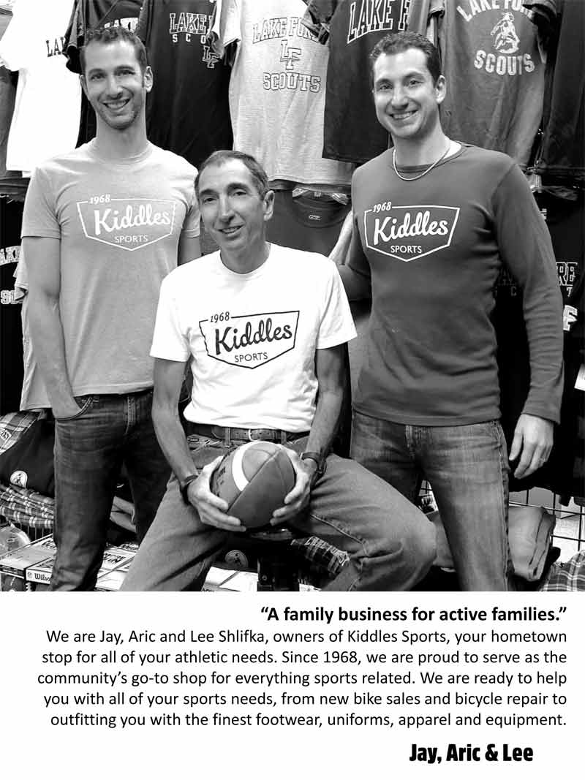
Photo by Kerri Sherman of Bloom & Focus Photography
Editor’s note: Letters to the Editor represent the writers’ opinions and not necessarily those of Daily North Shore.

