

Cycling in winter: Don't wait to use that bike you got for Christmas
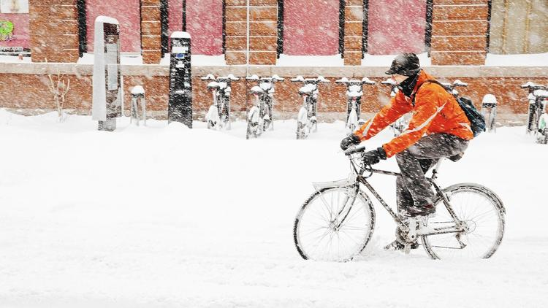
Winter biking is gaining in popularity. Following a few simple tips can make it easier. (Diego Rojas / EyeEm)
Debbie Carlson Chicago Tribune
The days may be short and the weather cold, but that doesn't mean an end to bike-riding.
It does, though, mean a little more planning. Bikes need greater care in winter, and riders need gear to protect them from the elements. They also should be more cautious when hitting the road, bike experts say.
Use disc brakes if the bike can accommodate them, as they are great for wet conditions, say both Josh Stone, director of Middle Tennessee State University's bike shop and bike programs, and Steve Clark, bicycle friendly community specialist for The League of American Bicyclists.
Lube the chain. Jay Shlifka, owner of Kiddles Sports in Lake Forest, Ill., says to make sure the chain is well-lubricated throughout the winter, which he said is "the heart of the bike." Stone likes Pro Gold lubricant ($12) during winter since it doesn't attract grime.
Go wide. Wider tires are better in winter, and Shlifka says lowering the tire pressure flattens the wheel, allowing for better grip, and wheels will be better shock absorbers against the harder winter ground. Another option for tires is to buy those with stainless steel spikes, which help during icy and snowy conditions, says Gaynor Collester, supervisor, product support for Performance Bikes, which has stores in several states.
Know your limits, and layer up. Dr. Brad Thomas, chief of sports medicine, department of Orthopedic Surgery at Harbor/UCLA Medical Center, says winter biking is fine for anyone, although he cautions people with asthma, heart conditions or circulation problems to avoid the extreme cold.
When going out, the bike experts suggest wearing three basic layers, starting with a synthetic-fiber shirt closest to the skin. Cotton T-shirts are no-nos, they say, because cotton traps moisture (synthetics whisk it away). A second layer, like merino wool or another synthetic fiber will add warmth. The outer layer should be a fitted jacket that's both wind- and water-resistant, preferably in a bright color visible to motorists.
Take care of fingers, toes and head. "You need to keep your hands warm. Biking in cold weather is like sticking your hand out the car window," Shlifka says.
Sports gloves for skiing or snowboarding work fine, Thomas says.
Some cyclists wear shoes a size larger to accommodate thicker socks. Stone wears long, wicking, semi-compression socks, such as Swiftwick Performance 12 ($15.99). Toe warmers tucked into shoes work well. For super-cheap protection, Clark suggests reusing bread bags to wear over socks and in shoes. The plastic does a great job keeping out the cold, he added.
The bike experts also recommend balaclavas, which cover the head and neck, except parts of the face. These are thin enough to fit under helmets.
Be careful. In winter, pavements are slick, and there's lowered visibility for motorists and cyclists. Clark says cyclists may have to rethink their usual routes and look for streets that are consistently plowed and have better lighting, which sometimes means busier streets. That's why using flashing front and rear lights and wearing bright colors is important, he said. It's better to bike more slowly too. Cyclists are likely to hit black ice or some other obstacle that can cause a fall. In that case, Thomas said, keep your hands and legs on the bike to stay tucked. "The way you break your wrist is by sticking out your hand to cushion your fall," he said.
Debbie Carlson is a freelance writer.
Copyright © 2016, Chicago Tribune

