

Art in the Every Day
by Kelly Konrad • April 29, 2016
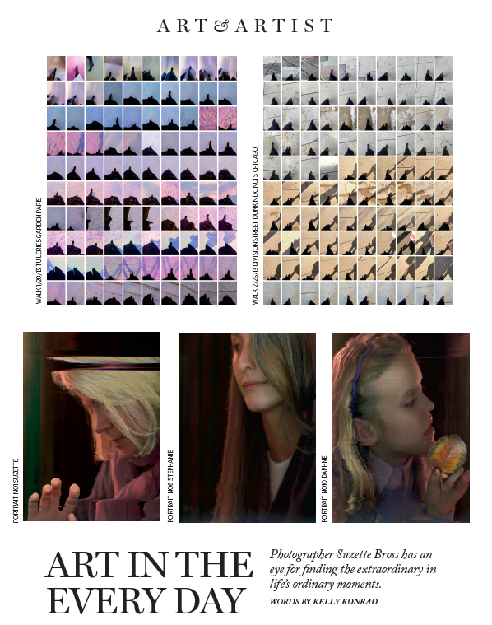
Renowned Chicago photographer Suzette Bross spent her youth in Lake Forest. After leaving the area for high school, a combination of love and graduate school brought Bross back to the area. Earning an MFA from the Institute of Design at IIT, Bross has taught at Columbia College Chicago, the Milwaukee Institute of Art & Design, and Northwestern University Medical School. She has established herself as a premier photographic artist with works in the permanent collections of the Art Institute of Chicago, the National Gallery of Art, the Museum of Contemporary Photography, and the Block Museum on Northwestern’s Evanston campus. Bross’ 2016 calendar is filled with exhibitions at the Chicago Artists Coalition (CAC), the Arts Club of Chicago, the University of New Mexico, and the Newport Art Museum. Her solo exhibition at the CAC’s Bolt Residency opens June 3.

Today a downtown denizen with her husband and three school-aged children, it was a 2014 artist’s residency at Ragdale in Lake Forest that allowed Bross to reconnect with her childhood. “Ragdale didn’t exist when I was growing up in Lake Forest—not as it does now—but working there brought back the past,” she recalls. “Sylvia Shaw Judson (famed sculptor and daughter of Ragdale architect Howard Van Doren Shaw), made a sculpture of a childhood friend and her mother that is on the fountain in Lake Forest’s Market Square. The only working bicycle at the residency was a Schwinn Varsity 10 speed, the exact same model my parents gave to me. My old bicycle was purchased at Kiddles Sporting Goods shop—which is still there—and I passed the shop and the statue on my borrowed bike just as I had when I was a child,” she notes. “Evidence of my past was everywhere in my present moment at Ragdale; the objects are visual mementos of my childhood which informs the way I see and work today.”

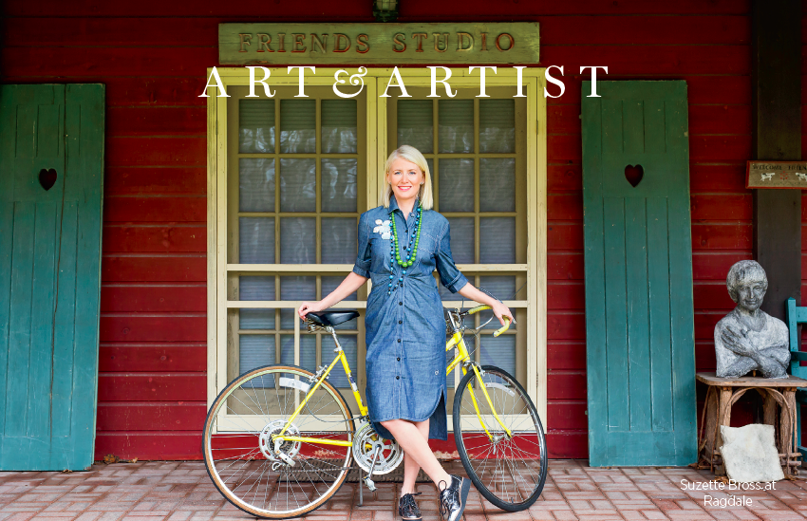
Photography is Bross’ forte—and a passion that is in her blood. “I’ve always been interested in photography. My grandfather was a talented amateur photographer, as was his father, and grandfather,” she reflects. “My grandfather gave me my first camera, a Kodak 110 Instamatic, which is an awesome ‘70s piece of plastic; later, I inherited his Hassleblad from my father, which I still use today. Eventually, my grandfather gave me his whole camera collection, which was an amazing gift,” Bross notes.
Bross’ work is extraordinary in its simplicity. She admits that an artistic obsession takes over when she finds a new muse, even in something as simple as the color field created in passing traffic. Her “Walks” series, collages of snapshots featuring everything from feet to shadows, was taken, surprisingly, with her Smartphone camera. The series captures her movements frame by frame in various places she went during the course of her day. How she arranges the images gives the composite work a sense of fluidity and movement. Her photographs create an opportunity for an image to be appreciated in a variety of ways. When viewing images from “Walks,” one might see a photograph of a foot in motion while another may see a visual representation of the grace in being able to take a walk outdoors.
Her latest body of work, a series of portraits, gets rid of the camera entirely. “After spending so much time on the ideas of landscape, I wanted to think again about portraiture and how we see ourselves through the lens of technology which is so intertwined with our lives today,” Bross says. “With the advent of digital photography, the promise of mechanical painting that the founders of photography strived for has come true. This phenomenon is a thread in my own work. I try to look at the way we see the everyday in a new way.”
For more information about Suzette Bross and her work, visit suzettebross.com.

